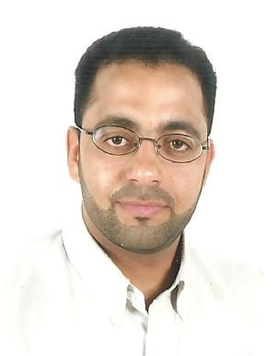**Basheer Mahdi Ahmed Jassim**

**Home No 856 – Road 4225 – Block 542**

**Contact No: 39776277 – 36866440 – 36776277**

**WhatsApp contacts: Basheer Mahdi 39776277**

[**b13q@hotmail.com**](mailto:b13q@hotmail.com)

**Personal details:**

**\* Nationality:** Bahraini

**\* Passport No:** 1749253

**\* CPR No:**  751202703

**\* Date of birth:** 18 / 12 / 1975

**\* Marital Status:** Marriage – Three Sons

**Occupational Goal:**

Seeking for interview to obtain an enter-level position to suitable my qualifications.

**Educational Qualifications:**

:

**\* 1997 – 1999**  National Diploma in Electrical Section.

**\* 1996 – 1997**  First Diploma in Electrical Section.

**\* 1994 – 1995** Jidhafs Secondary School “In Technical”.

**\* 12 May 2011** (AUTHORIZATION CERTIFICATE).

**Training & Work Experience:**

:

:

**\* 1 Week** 1- Trainee as a Cable Testing on Training Center on Sitra side.

**\* 3 Months** 2- Trainee as a Electrical Technicians an British Airways.

**\* 2 Months** 3- Trainee as a Technical Sales in Nortel Networks.

**\* 2 Months** 4- Trainee as an Electrical as assistance in Habib Awachi.

**\* From 2000 to Feb 2013** 5- Working in Authority of Electricity and Water in Distribution Department.

**\* From Feb 2013 to 31/9/2019**  6- Working in Authority of Electricity and Water in Customer Service

Department.

**\* From Oct 2019 up to now** 7- Retired.

**Courses & Activities:**

:

:

**\* 1992** Learning English in Balghloot.

**\* Jan 2002 – to date** Member in Duraz Culural center.

**\* May 2001 – to date** Member in Central Statistics Organisation.

**Interests:**

:

:

**\*** Play football, reading, writing, travelling, internet and voluntary social activies.

**Additional Skills:**

:

:

:

**\*** English and Arabic Language communication skills – Well reading, writing and speaking.

**\*** Good in Software Microsoft Office Applications, Auto CAD.

**\*** Good attractive with people and work team.

**\*** Reading for any activity.

**References:**

:

:

:

**\*** Available uopon required.